Required readings: [SystemsArchitecture_NTC](https://docs.google.com/document/d/1veN4eiil2Lbrl23Z9OQ63Gidkd0_yw-_1zWwJ_I_ess/edit#heading=h.48cggh70rjxj)

# System Landscape

Changes:

* Vault App - Server
  + Need an enclave to sign transactions and a backend to store Algorand Address of accounts

# Site Map for Vault App:

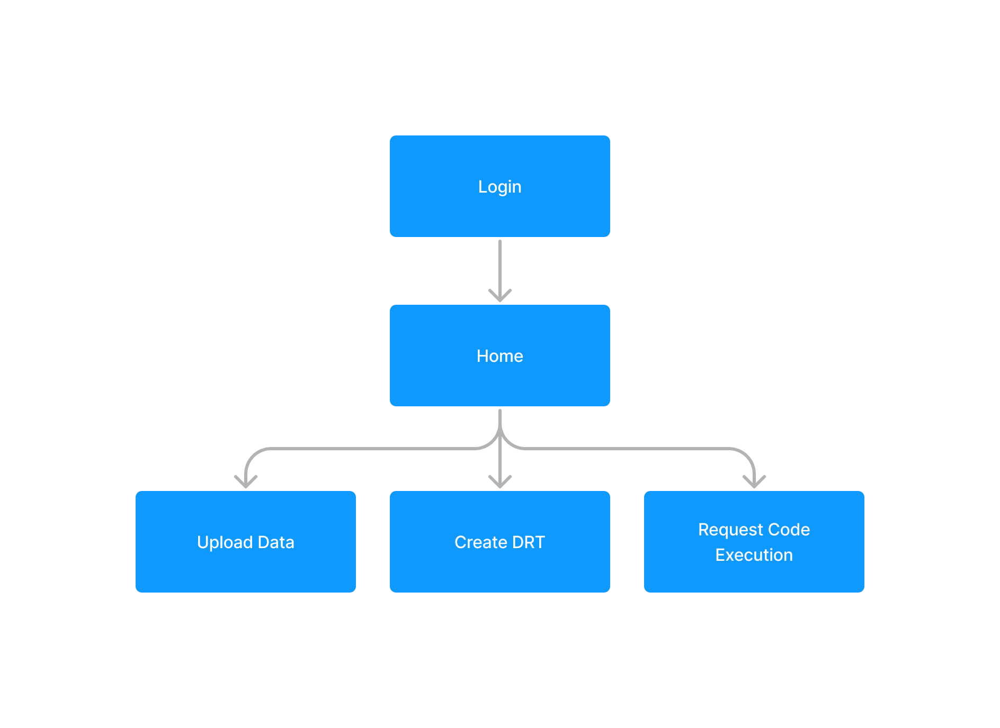

* Possibly one more page about a “marketplace” where user can buy DRTs

# System Flow

## 1. Upload Data:

4Users with existing algorand addresses - lower priority, can always just transfer assets

### Data → Data Package:

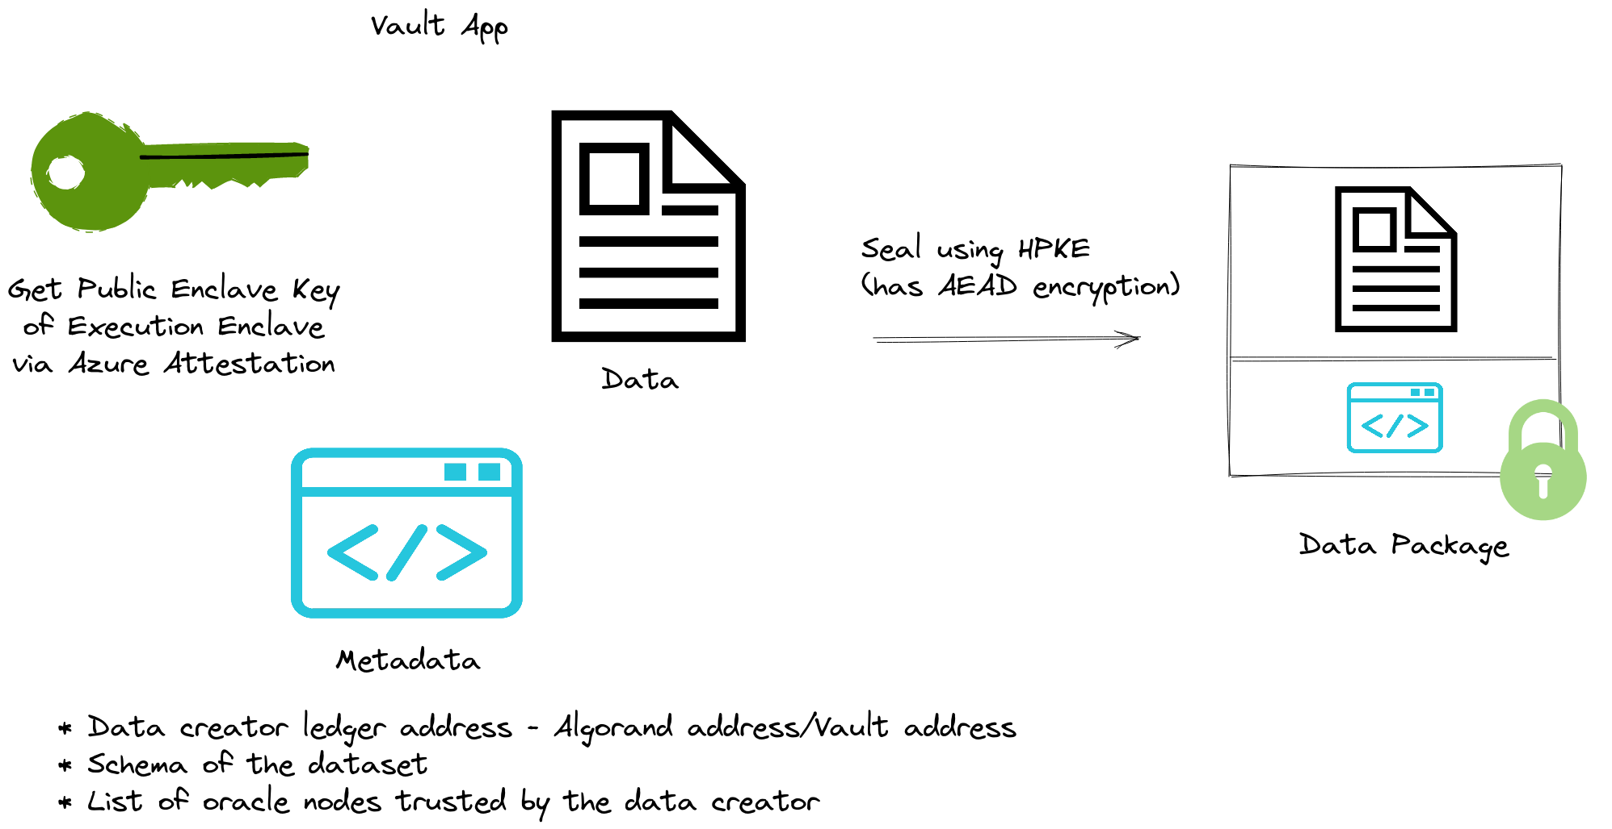

### Data Package → Object Storage:

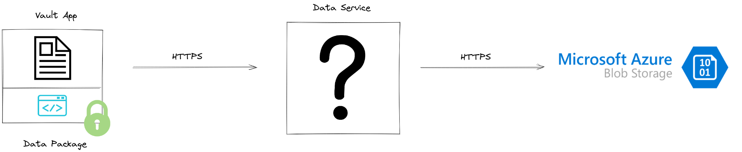

Data Service - Provides data package upload and management features

Do we need to build this out for MVP? Yes

Data Service - Component that interacts with Microsoft Azure storage.

## 

## 2. Create DRT:

### Example:

DRT asset JP created on Algorand’s TestNet - <https://testnet.algoexplorer.io/asset/93351201>

## 3. Buy DRT:

### Build our own marketplace:

“Marketplace” - be part of Vault App

Backend functionality is complex as both data creator and third party needs to sign transactions before the group transaction can go through.

This still needs to be planned out.

### Example:

I bought a DRT from JP for 3 Algos on Testnet.

*Morph is just an algorand account that I used and the name I gave the account.*

Morph to Morph DRT OptIn transaction: <https://testnet.algoexplorer.io/tx/BQ4AV2ATQTIFXDM424BQ3TPYZQ5P6FNCPDIVK2UVJGFTP4JRKEGQ>

Atomic Transfer:

JP to Morph DRT transaction: <https://testnet.algoexplorer.io/tx/BXAT2ZKJHOJG6S25Y4KTT4LBIMHIEDSBSKO664MDOPVXKHF3GCDA>

Group transaction overview: <https://testnet.algoexplorer.io/tx/group/PbY8%2BOLNetrUMo3B42jpmS3PzZhZehA%2BmWYv665q5ls%3D>

### Use Tinyman:

Tinyman is just a smart contract (application on the blockchain) so not user friendly.

Gary Lu investigation.

## 4. Redeem DRT:

## 

## 5. Run Code Execution:

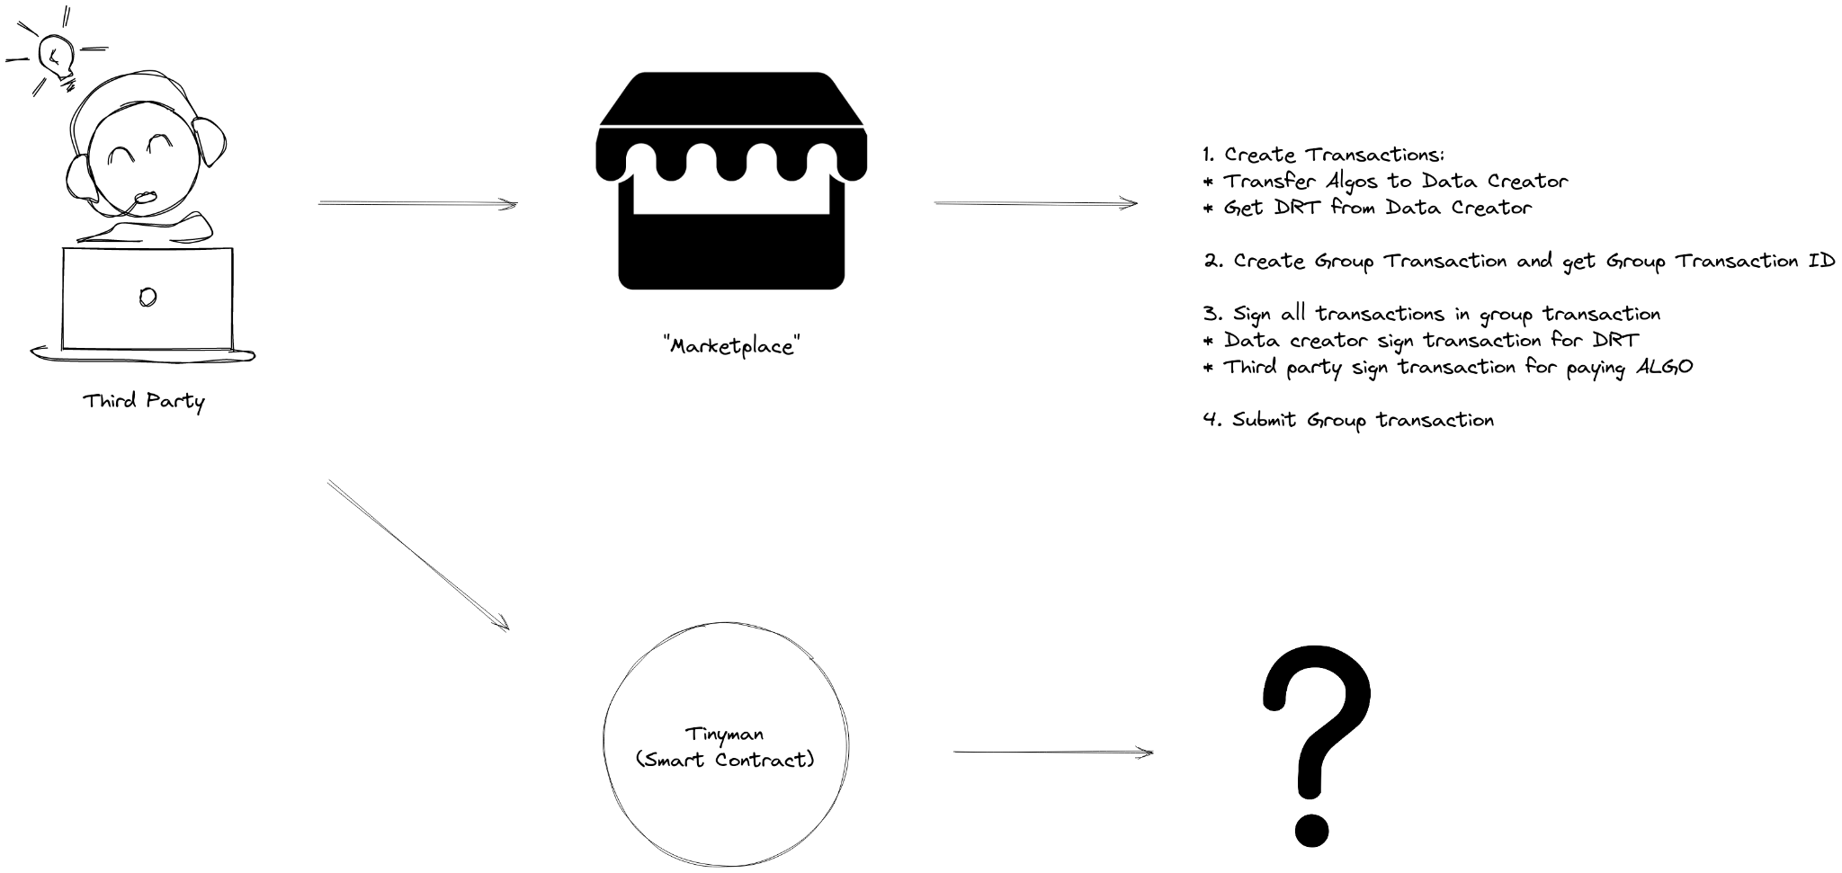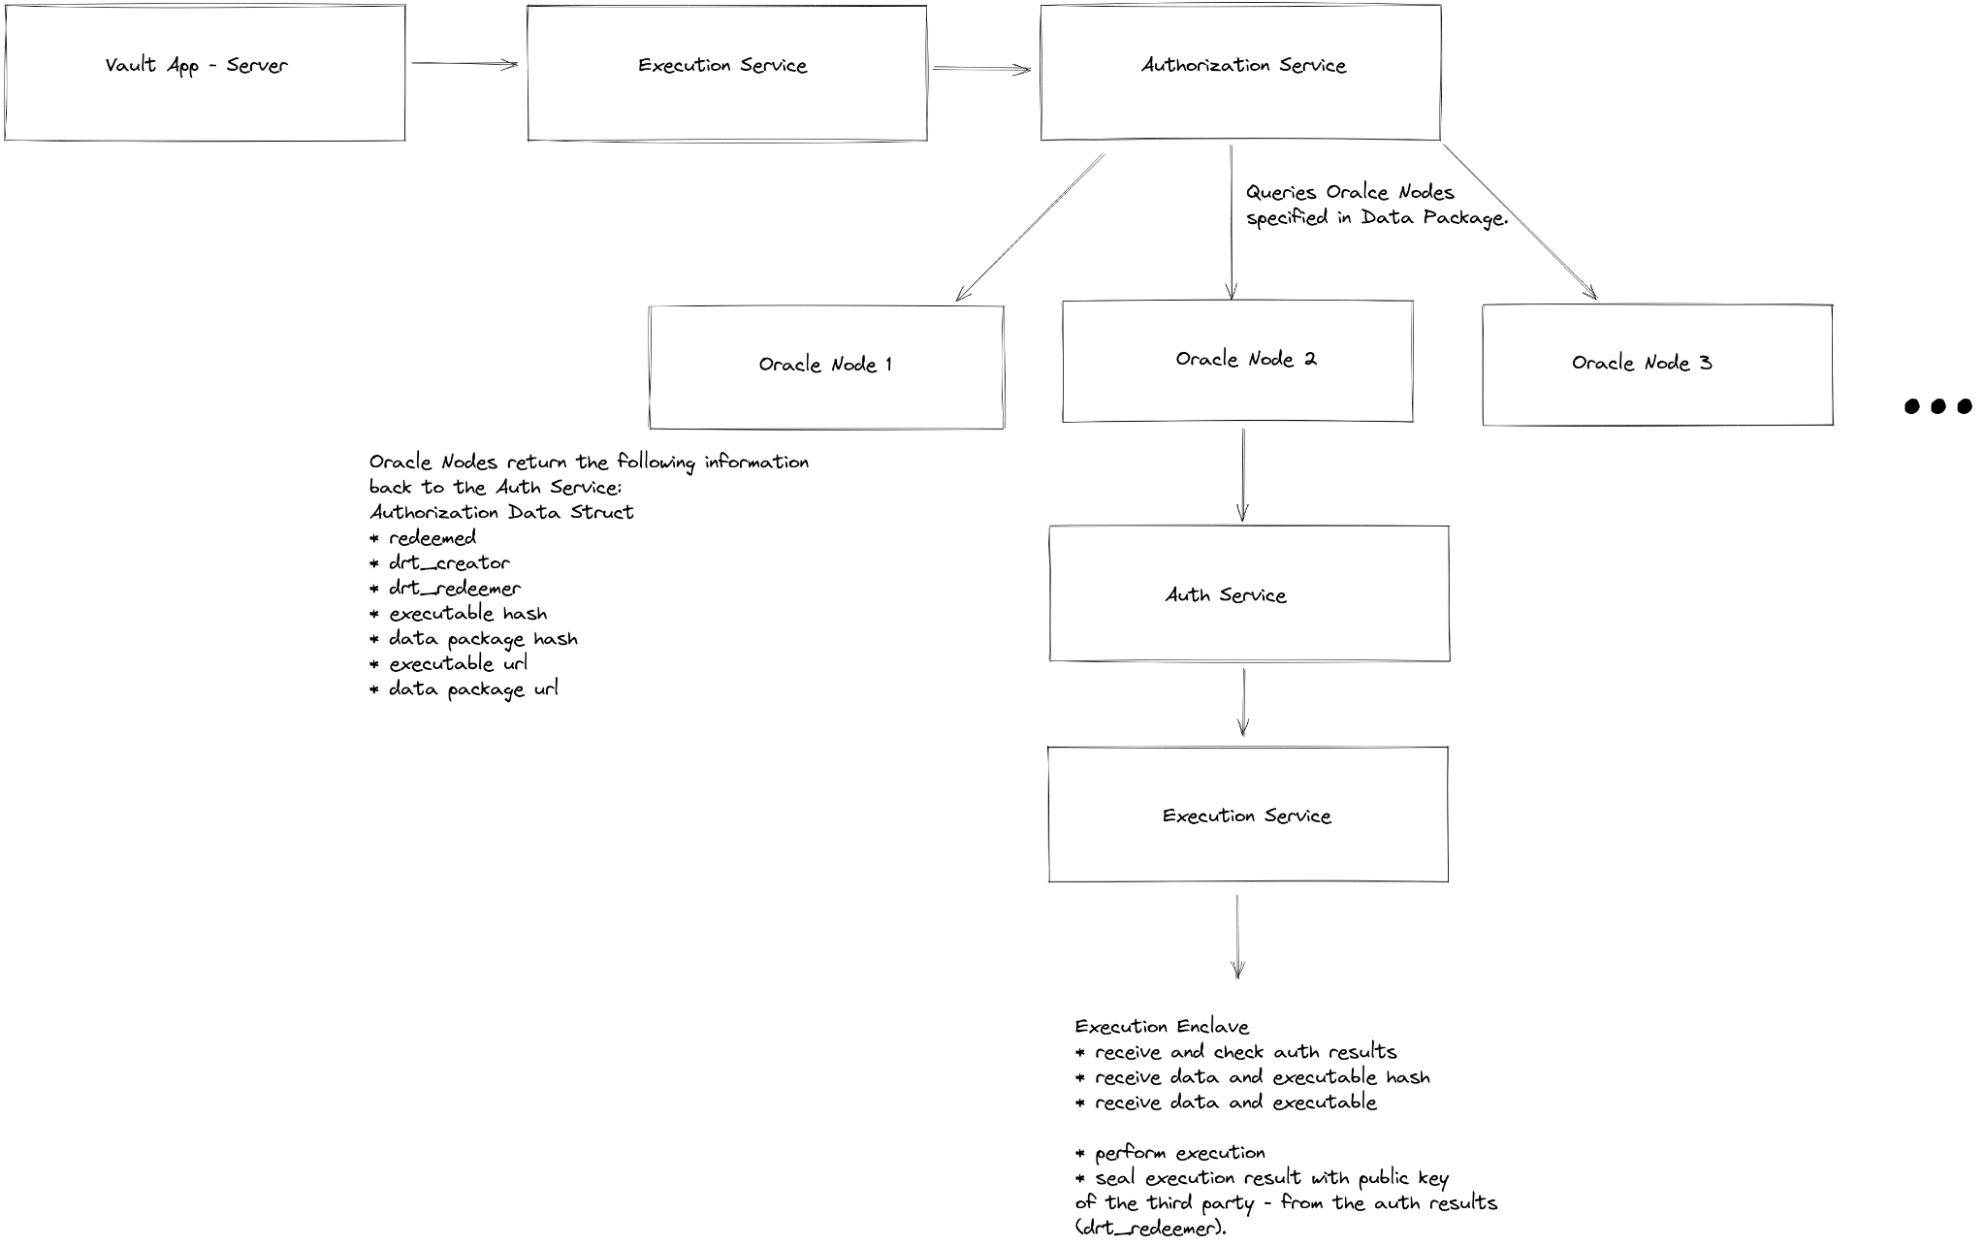

Vault App - Server will send transaction ID and DRT Asset ID to Execution Service.

Core inside Execution Enclave is the General Purpose Compute Platform:

* WASM runtime
  + Runs WASM binaries (code)
  + Passes data into WASM as memory
    - Limits? **256MB** Enclave Page Cache (EPC)

## 6. Data Pooling

### via Smart Contracts:

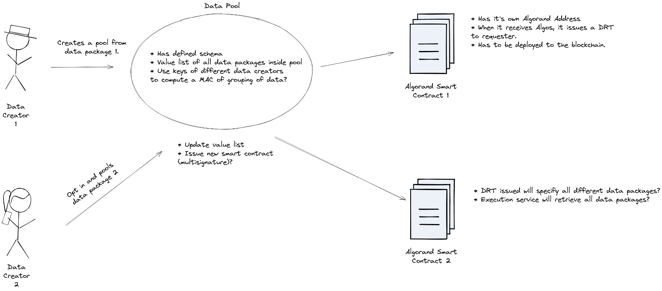

Very important value of the product

### via Algebraic Projection:

[Algebraic Projections & Data Rights](https://docs.google.com/document/d/18NIP8SWG3eczCx5HOMjAR80XHMAqLXK3SaE8KFDxq7s/edit#heading=h.4qfwcgeko1pc)

[ADR 2: Algebraic Data Rights](https://docs.google.com/document/d/1-XShHmAnPltEE4FY4AdxwvW7yDPxOeRcPpkI0bRWxJU/edit#heading=h.i0wxzahi1yex)

## 7. Other Items Not Planned

* Billing
* NTLS Tokens - Not MVP

DRTs to represent “digital property rights” but what it is currently is just an ASA asset with note fields.

We use the blockchain so that customers can transparently see transactions and DRT information on the ledger.